**Engineers for Exploration**

Dillon Hicks

**Save Polygons and Points as KML for GS Pro in** 

# Prerequisites:

QGIS 3.0.1

# Setup:

The machine that this documentation ran on was a Windows 10 computer, with no additional software included for GIS.

# 

# 

# 

# 

# 

# 

# 

# 

# 

# Documentation:

This is a follow up from a previous tutorial in which we created random points from QGIS to be used to randomly sample an area of interest. As a prerequisite, please create a polygon layer with random points held within a point layer as shown in the previous tutorial.

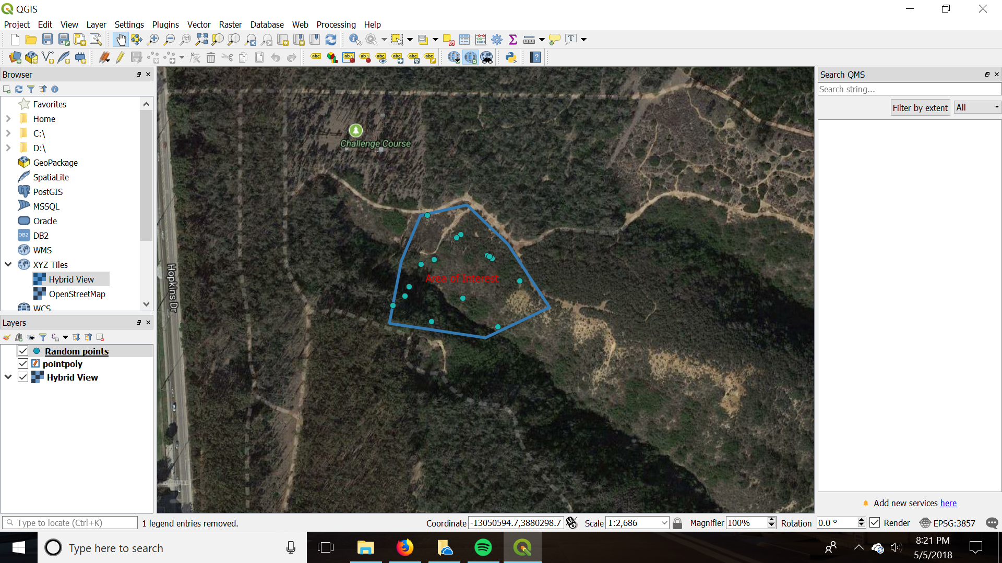

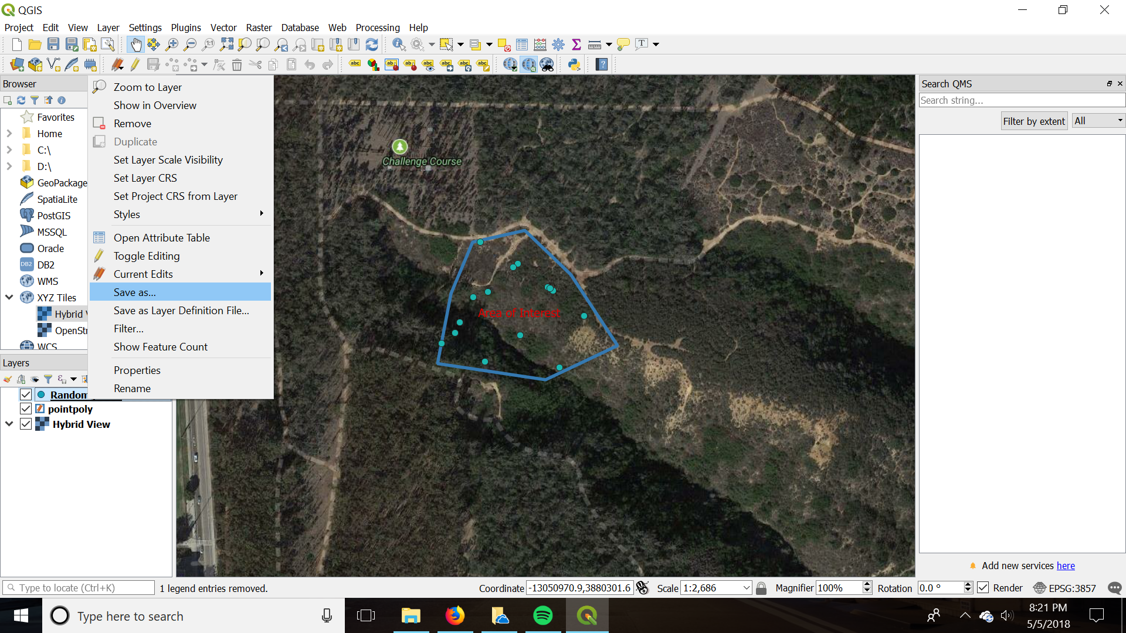

Right click on your point layer and click save as.

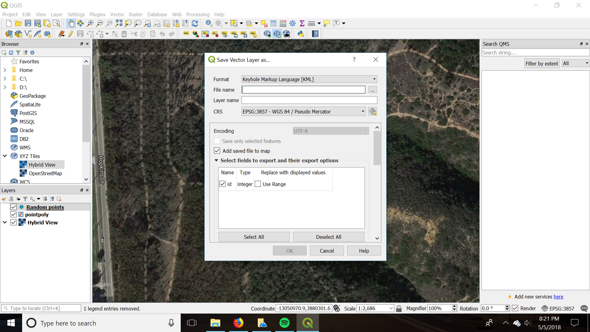

Save the layer as a Keyhole Markup Language [KML] as EPSG: 3857. You can also do this with your polygon as well. Now you should have two KML’s, one for the polygon and one for the points.

Now we can check whether our KML was created successfully and open your KML’s in Google My Maps. Create a Map, and then add a layer for your polygon and point layer. Click Import layer for one of your created layers and upload the KML you created, doing this for both KML’s that you created in QGIS.

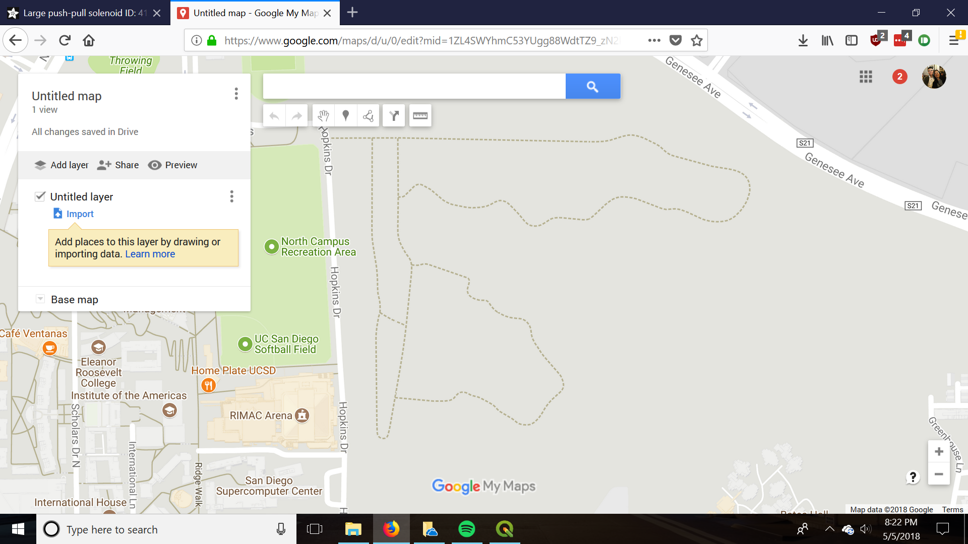

If both of your KML’s were created properly (which they should), both should show up on your map. Wasn’t that easy?

